NAME: SHRUTHI REKHA R

REG NO: 20BCE2702

SCREENSHOTS OF EXECUTION:

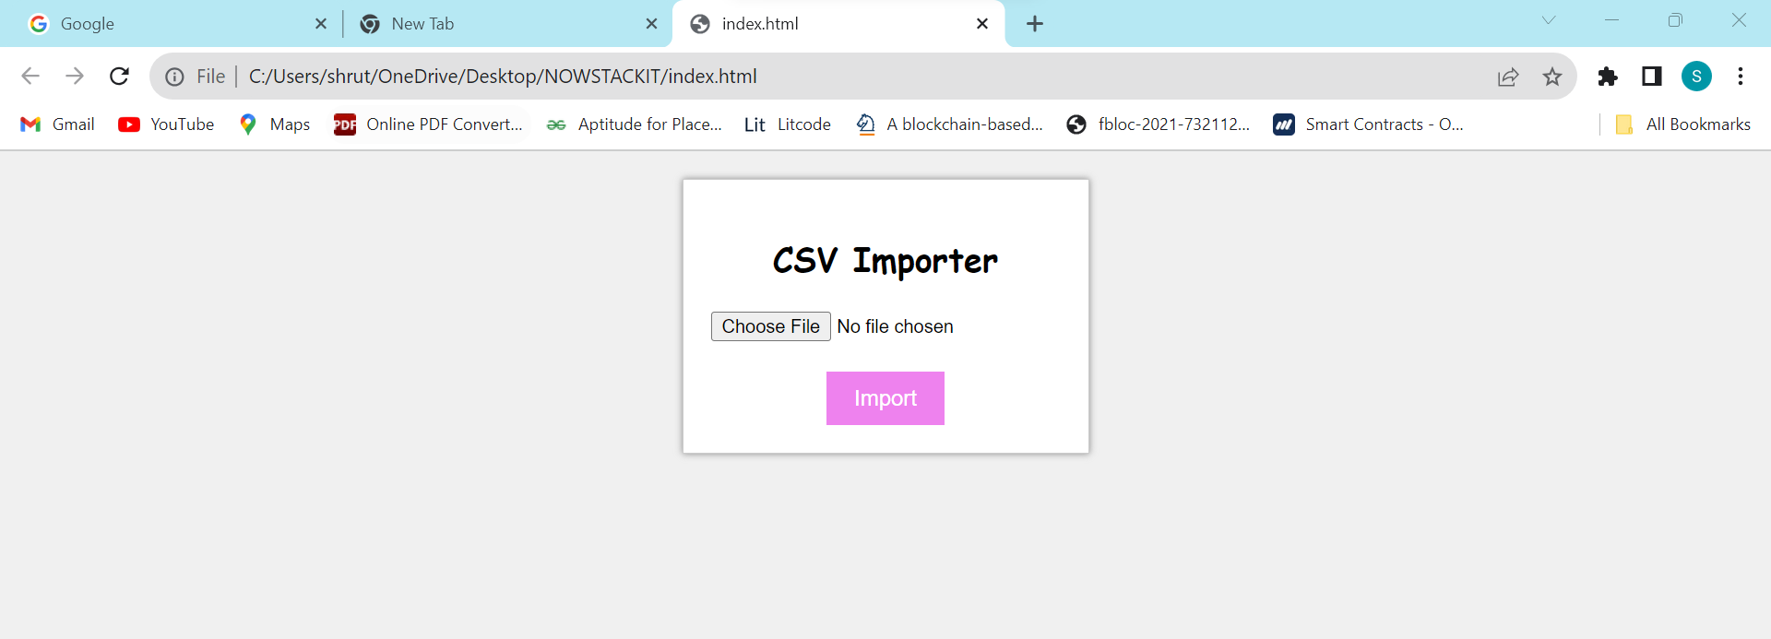

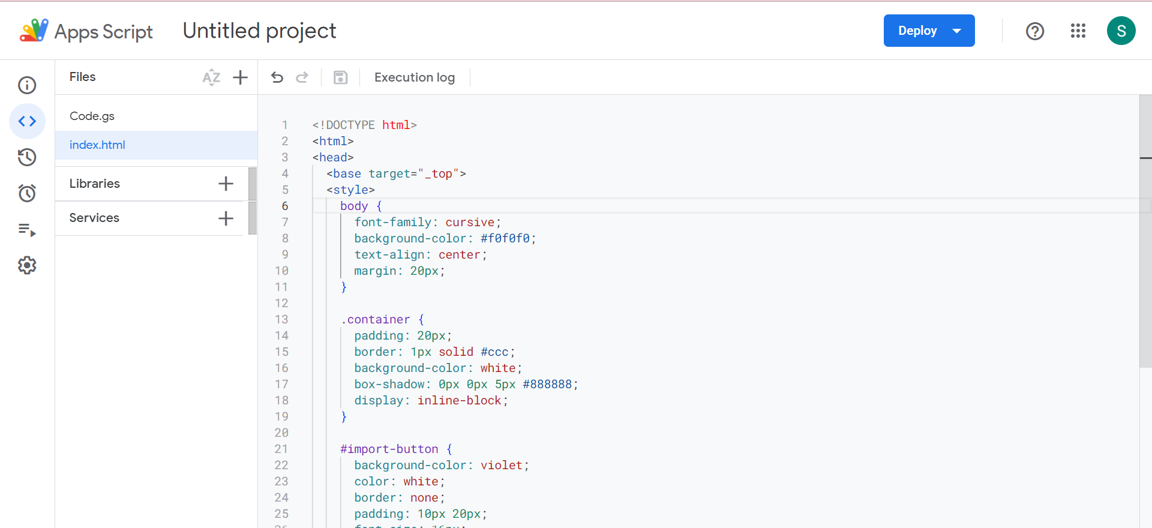

OUTPUT:

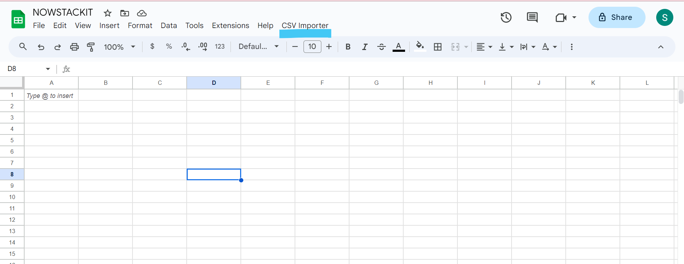

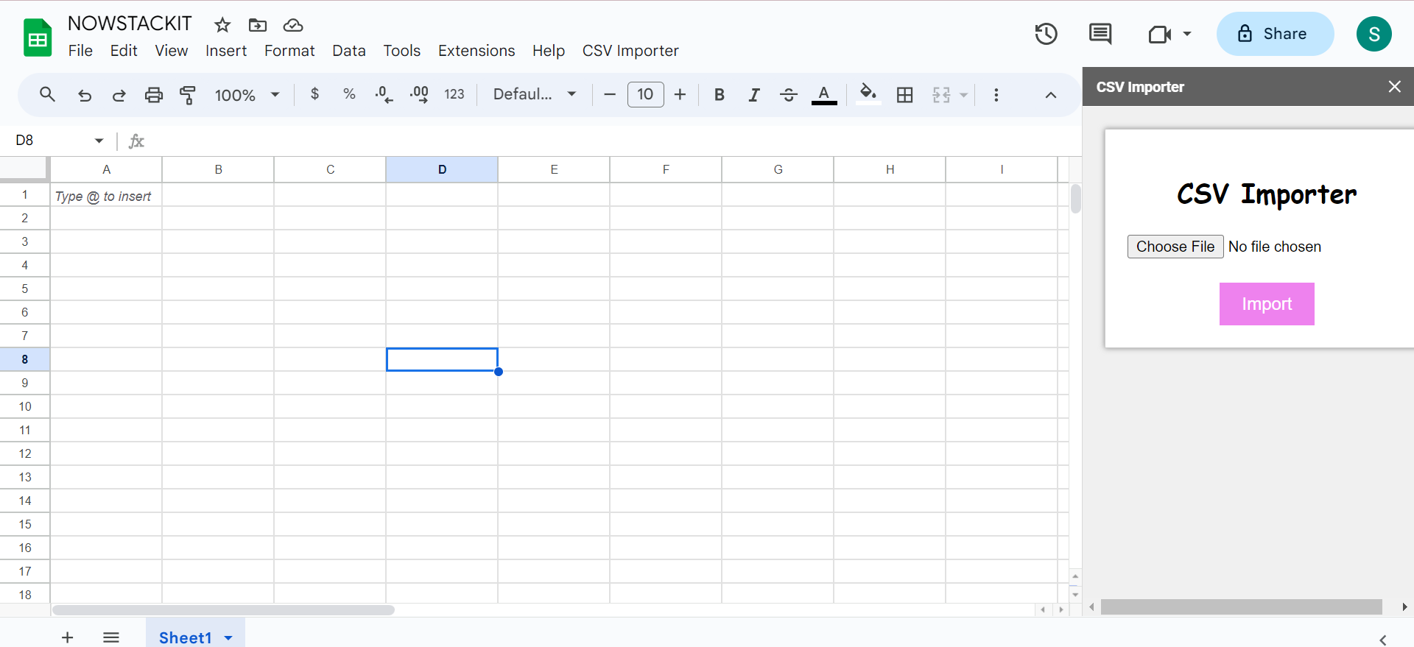

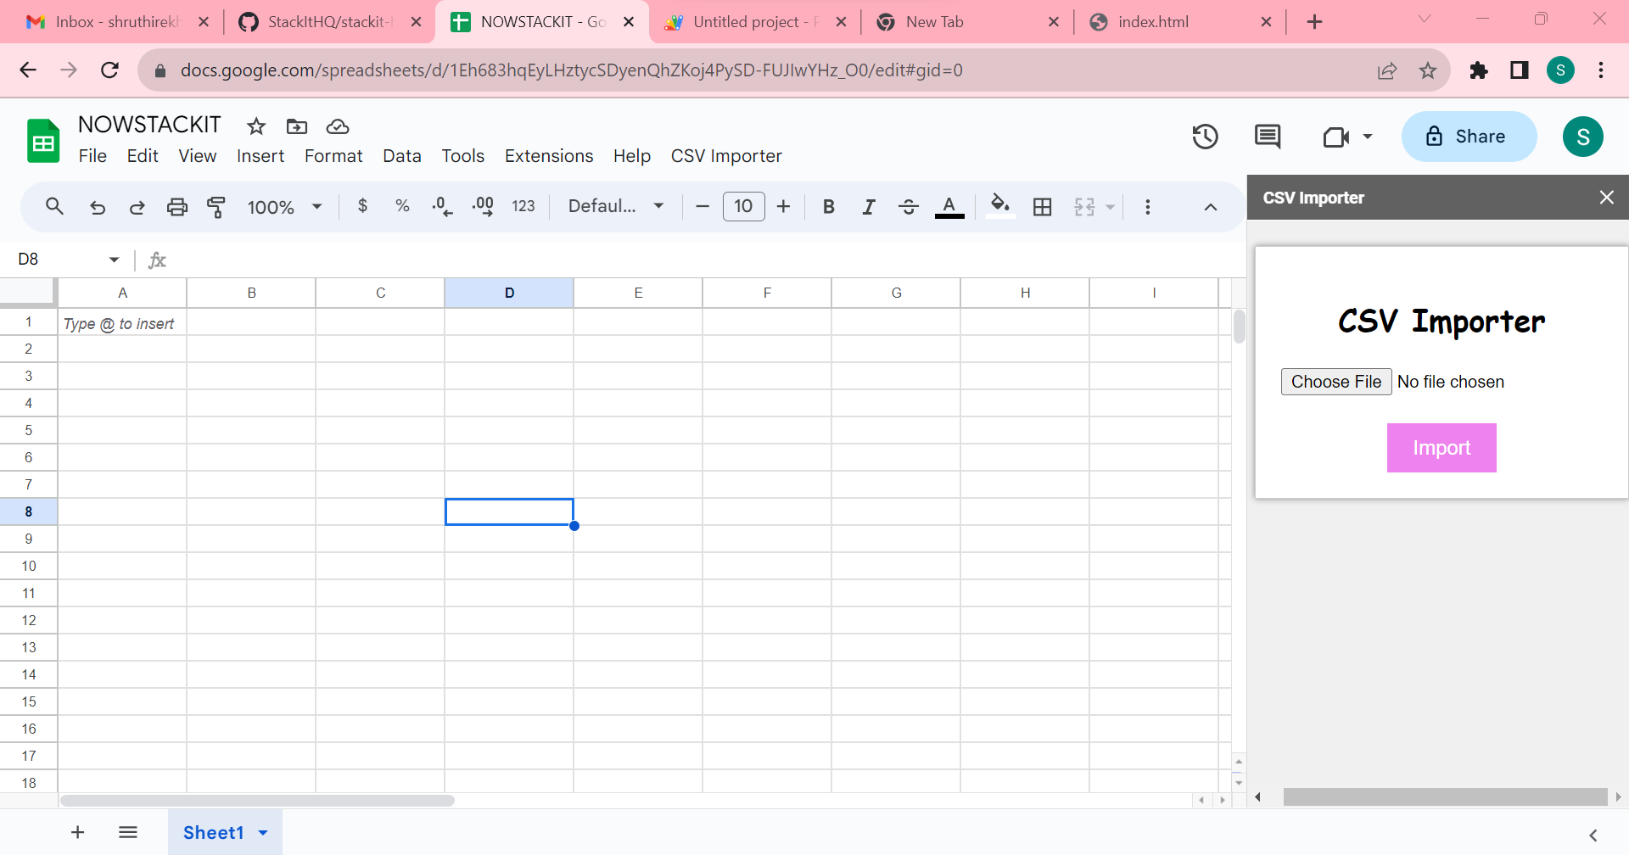

NOW SHEET 4 IS EXECUTING

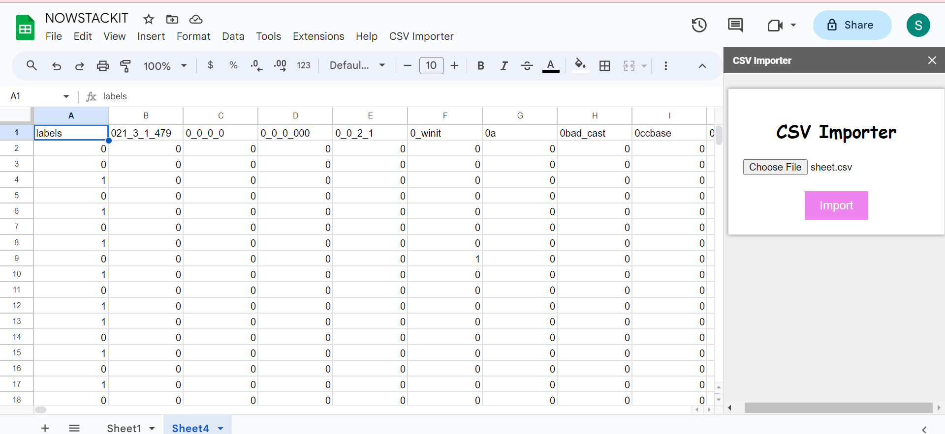

THEN IT MOVES TO SHEET 5 BECAUSE IT ALREADY LOADED DATA IN SHEET 4

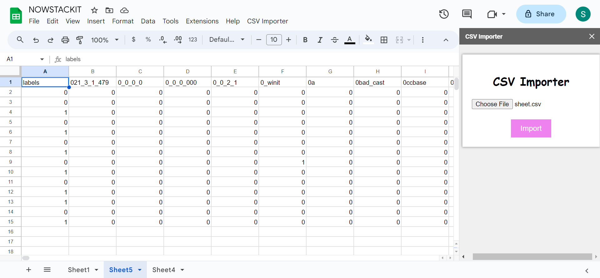

CONCLUSION:

HENCE, THE GIVEN PROBLEM STATEMENT IS SHOWN.